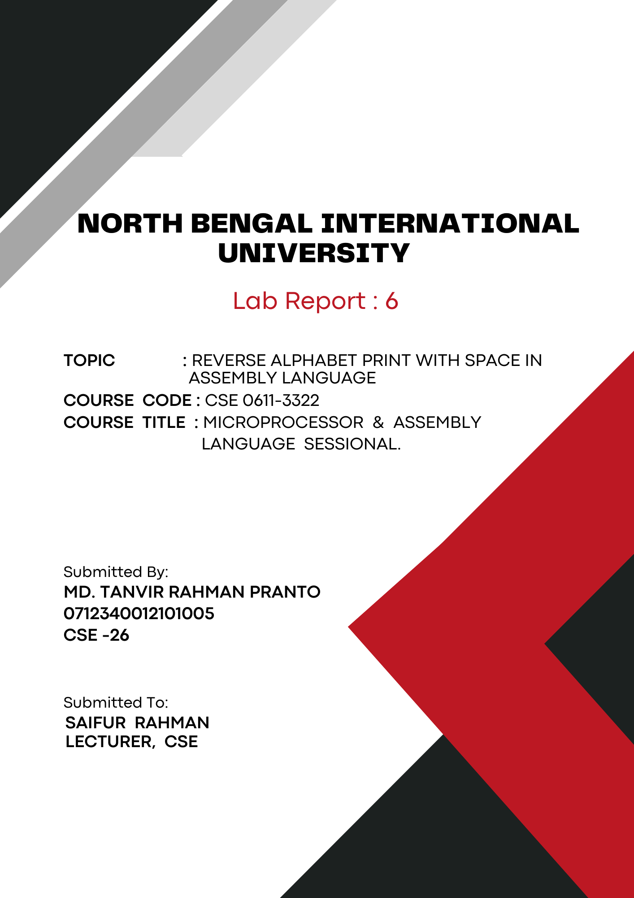
1

Theory: Assembly language is a low-level, human-readable programming language. It uses symbols instead of binary, mapping directly to machine instructions for specific architectures. It's ideal for high-performance or hardware-specific tasks.

Printing Characters from 'Z' to 'A' with Spaces in Assembly Language:
To print characters from 'Z' to 'A' with spaces in assembly language, start by initializing the data segment and loading the ASCII value of 'Z' into a register, such as `dl`. Use a loop to print each character followed by a space. In each iteration, decrement the character value in `dl` and output it using a DOS interrupt (21h, function 2). Continue this loop until the character 'A' is printed. Ensure to manage the loop counter and exit the program cleanly after printing all characters. This method demonstrates control flow, looping, and character manipulation in assembly language.

Code:
.model small
.stack 100h

.data
alph db 'Z' ; Start from 'Z'
space db ' ' ; Define a space character

.code
main proc
; Initialize data segment
mov ax, @data
mov ds, ax

; Set loop counter for 26 letters
mov cx, 26

level1:
; Display current character
mov ah, 2
mov dl, alph
int 21h

; Display space character
mov dl, space
int 21h

; Decrement to move backward in alphabet
dec alph
; Repeat loop
loop level1

; End program
mov ah, 4ch
int 21h

main endp
end main

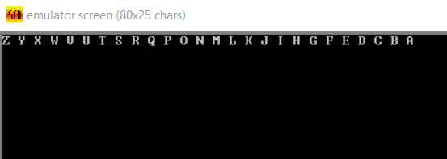
Output:

Conclusion: Through this code, we learn how to manipulate and display characters in reverse alphabetical order in assembly language. It shows the importance of initializing the data segment and using loops to handle repetitive tasks. By incorporating DOS interrupts for output, we see practical applications of low-level programming concepts and efficient character handling.

